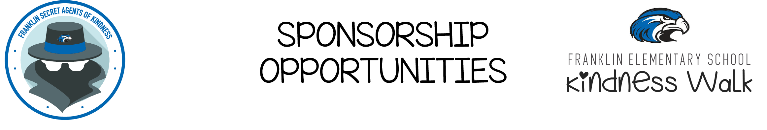
2401 Manor Lane
Park Ridge, IL 60068
Dear Potential Sponsors,
The Franklin Elementary School PTA is a non-profit, volunteer organization dedicated to enhancing the educational experience for all Franklin students. We bring together parents, teachers, students and local businesses such as yours to support our school staff, provide outstanding enrichment opportunities, and build a strong school community.
Why We Need Your Support
Our PTA works to raise funds needed to help ensure critical resources and programs continue at Franklin School. We strive to provide extra and needed resources and programs that will enhance the education that students receive at Franklin School, such as cultural arts programs, anti-bullying and anti-drug campaigns, as well as published author visits with our students. These are just a few important programs, which would not be available without the fundraising efforts of the Franklin PTA.
This year’s KINDNESS WALK is our biggest fundraiser of the year and will be held on Friday, October 11, 2019 at the school. We ask each to student to go out and get donations from family and friends for their participation in this healthy and fun walk/run event. As a thank you, the children pay it forward with an act of kindness of their choosing for each donation they receive! It is wonderful way to teach giving back and spreading kindness throughout the community.
To ensure that these critical programs continue at Franklin, we are asking for your help by becoming a sponsor. Your support is very important to the success of this event.
Sponsorship Levels | Platinum  $1500 | Gold  $1000 | Silver  $500
Company Logo on Digital Platinum Sponsorship Banner on Franklin PTA’s public Facebook page, private Facebook group and Homepage of FranklinPTA.com | X
Company Logo on Raise Craze website that goes out to all the donors and families | X | X
Company logo PTA website + “thank you to our sponsors” poster at Franklin Elementary | X-Large Logo | Large Logo | Medium Logo
Live recognition on day of the event | X | X | X
Sponsor feature on PTA weekly e-mails + newsletters that go home to students | X | X | X
Company logo on Membership Toolkit | X | X | X

Kindness Walk Sponsorship Form
We would greatly appreciate if all sponsorship forms and checks are received by Friday, October 4, 2019.

Business Name: ________________________________________________
Contact Person: ________________________________________________
Sponsor Address: ______________________________________________
Phone Number: ________________________________________________
E-Mail Address: _______________________________________________

Please indicate the desired level of sponsorship or donation type:
______ Platinum Sponsorship of $1,500
______ Gold Sponsorship of $1,000
______ Silver Sponsorship of $500
______ I would like to donate bottled water for the Walk-A-Thon. Q=600 bottles
______ I would like to donate gallons of water Q= 45 gallons

______ I would like to donate 2500 3 oz. Dixie cups

**Please make checks payable to Franklin School PTA, Memo: Walk-A-Thon 19-20, and mail to 2401 Manor Lane, Park Ridge, IL 60068
Questions? Company logos can be sent to Laura Gainor at laura.gainor@gmail.com. Please call Courtney Bowles at 310-403-3825 to arrange for donation pick-up.
THE PTA SINCERELY THANKS YOU FOR YOUR SUPPORT AND GENEROSITY!!

