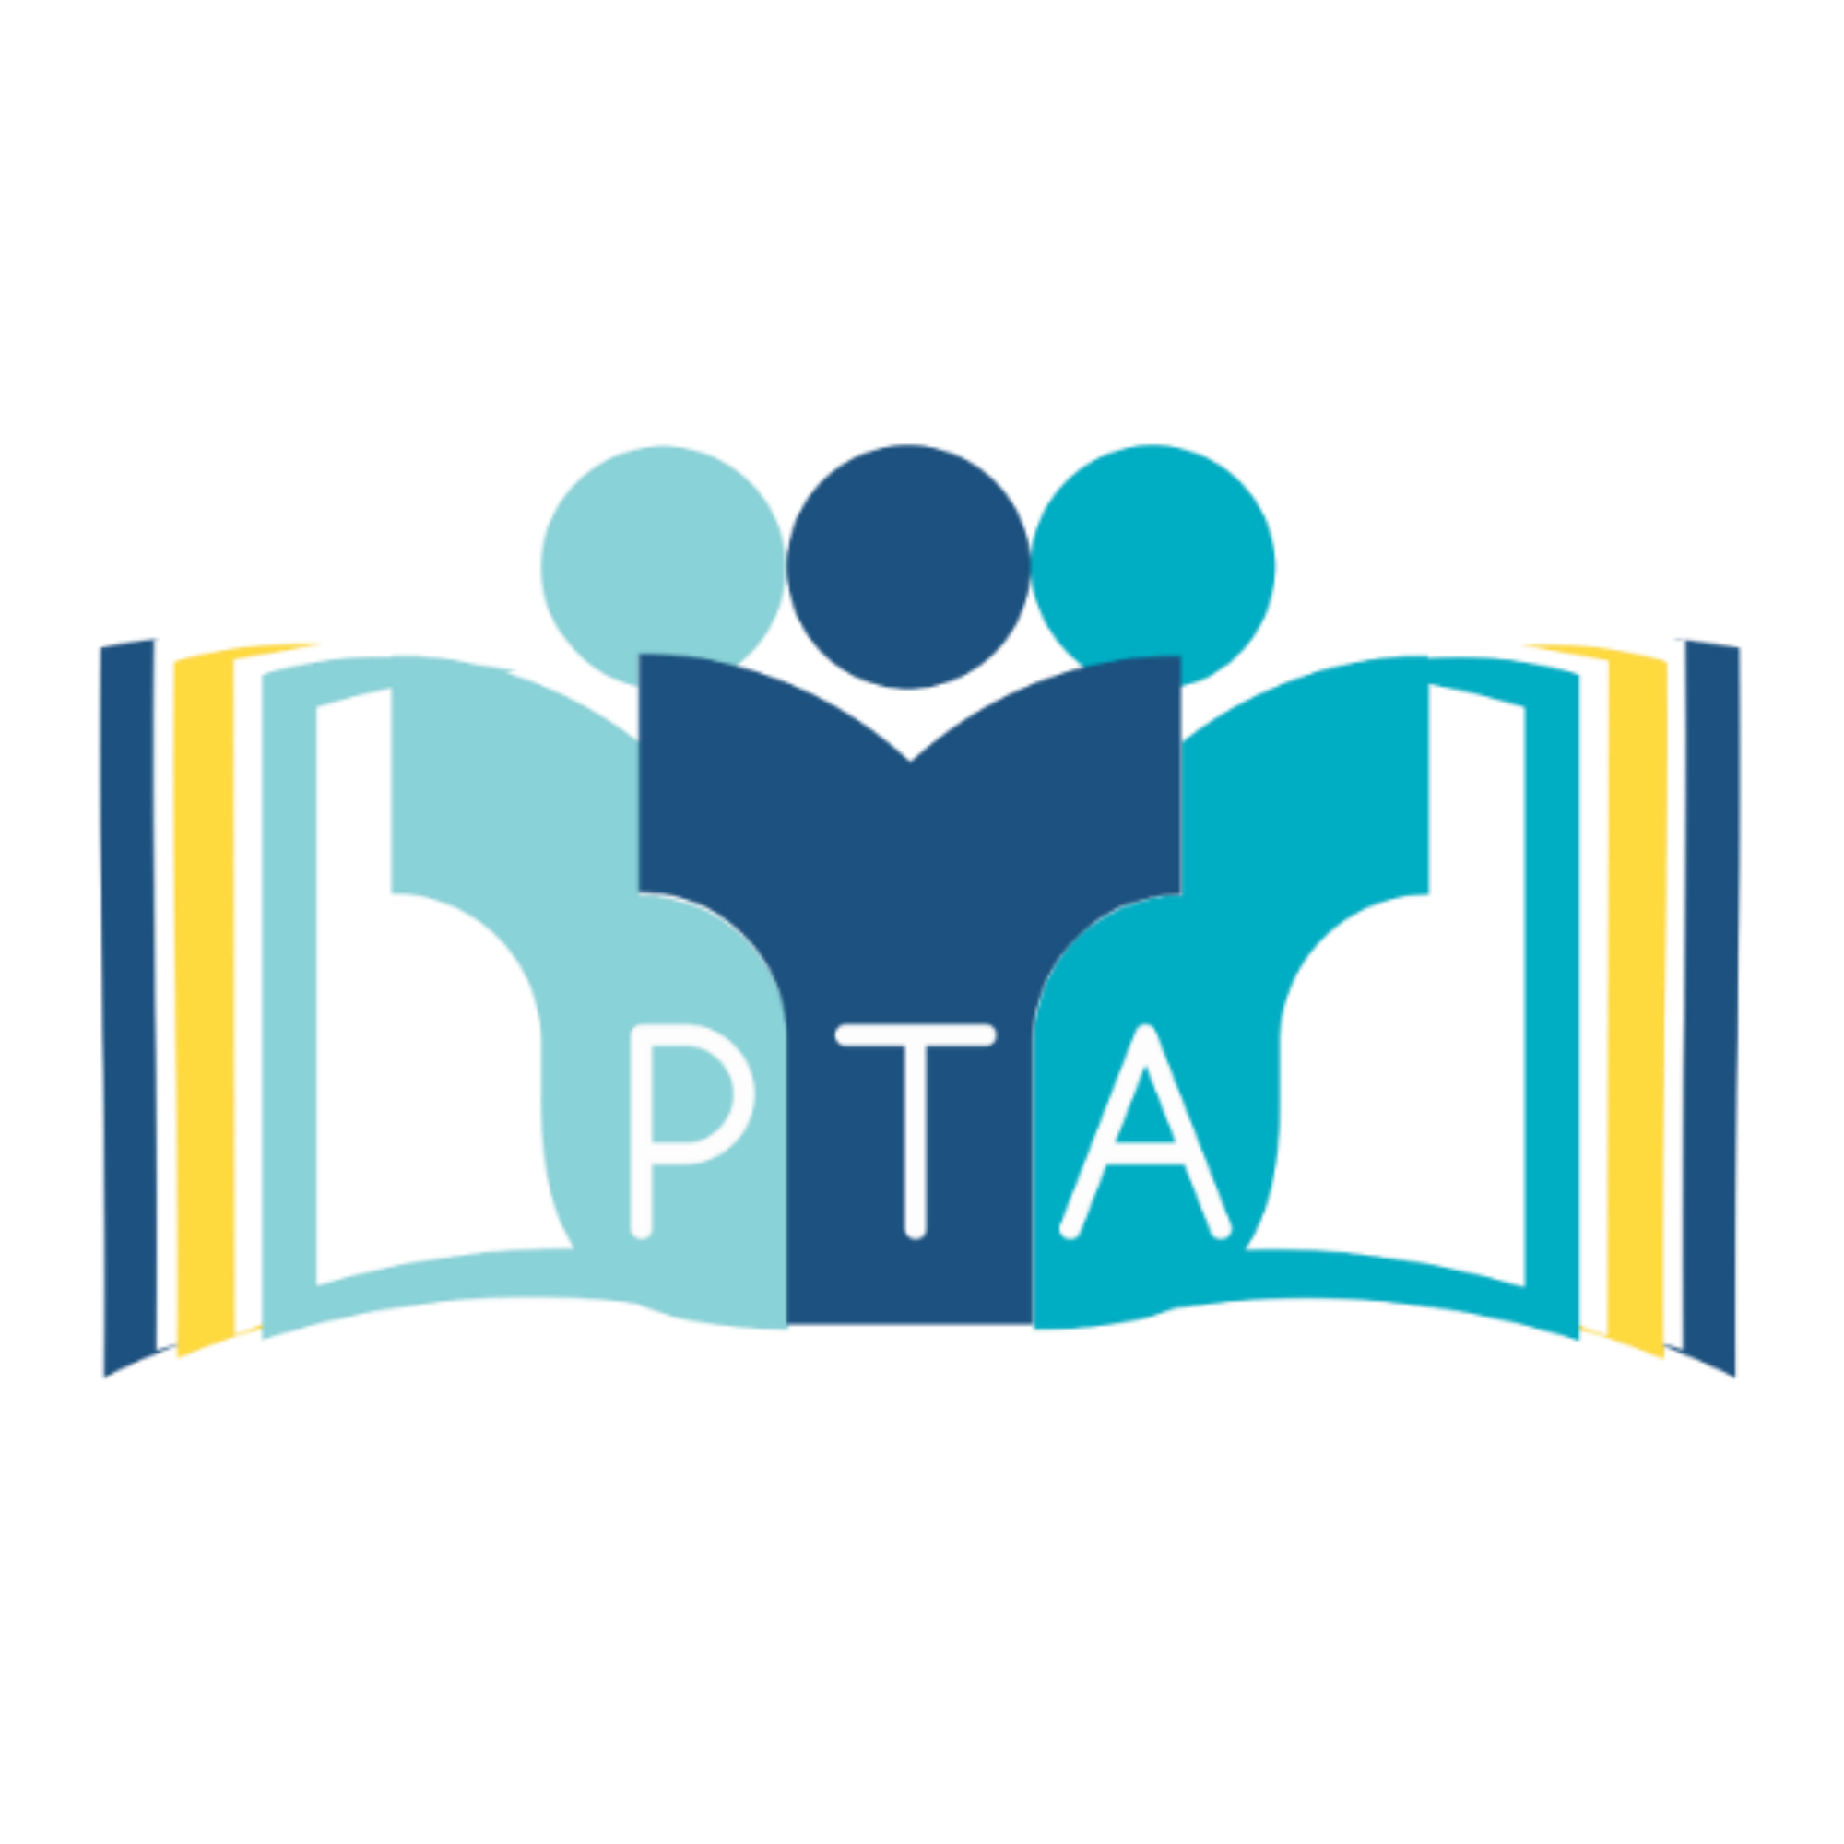
Franklin PTA - Teacher Grant Request Form

The PTA will begin collecting grant proposals on Monday, August 24, 2022 for the 2022-2023 school year.

Proposals may be for projects, activities, books, equipment or anything that enhances the academic lives of children at Franklin. Teachers are also encouraged to submit proposals that will benefit their individual classrooms or grade level. We would like to also encourage grants that offer school-wide access to students, teachers and/or parents.

All grant requests below $500 will be reviewed by the members of the 2022-2023 PTA Board. All grant requests above $500 need be presented and voted on at a monthly PTA meeting.

Please place your completed form in the PTA box in the school office. Grant requests need to be approved by Mrs. Williams, the Franklin Principal, to ensure the proposed request fits within the educational goals of Franklin School and to determine if the PTA is the appropriate avenue to obtain funding. The PTA Board will then review requests and present the grant request at the PTA meeting for a vote. We look forward to hearing about your project!

Any questions? Please contact the PTA President at president@franklinpta.com

Thank you,
Liana Madura, Franklin PTA President

DATE:
SUBMITTED BY (INDIVIDUAL/GROUP):
DESCRIBE PROJECT/ITEM TO BE PURCHASED:
COST/DOLLAR AMOUNT REQUESTED (ITEMIZE ALL COSTS ASSOCIATED):
SUBJECT AREA/GRADE LEVEL:
WHAT LEARNING/SCHOOL OBJECTIVES DOES THIS ADDRESS (WHO BENEFITS, HOW, AND FOR HOW LONG?):
HOW WILL YOUR STUDENTS BENEFIT YOUR STUDENTS?
HOW WILL YOUR STUDENTS USE THE REQUESTED MATERIALS?
WHAT IS YOUR TIMETABLE (BY WHEN DO YOU NEED THE FUNDING):
IF THERE IS ANYTHING ELSE YOU WOULD LIKE TO ADD, PLEASE FEEL FREE TO SUBMIT ADDITIONAL INFORMATION:

